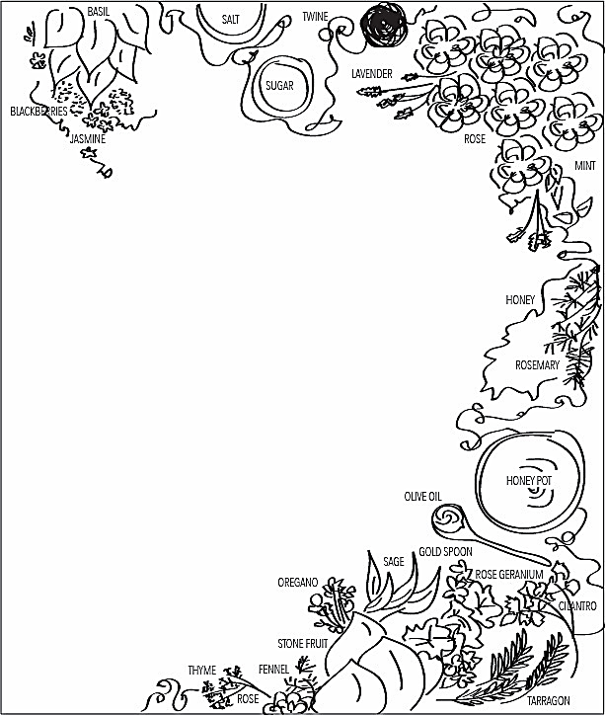
RECIPE ROUNDUP!
SHARE YOUR RECIPES!
“Legends and Flavors: Culinary Traditions of our Ancestors”
A Native American Traditional Recipe Book
The Community Health Representatives (CHR) Sub-Department is in the process of developing a Native American Traditional Recipe Book!
The recipe book will feature a collection that highlights Native American traditional recipes and the stories behind them. Submitters aren’t required to be tribal members of the Grand Traverse Band. We recognize that not all individuals with GTB descendant backgrounds are enrolled members of the Grand Traverse Band, yet they often possess valuable cultural connections and ancestral ties. By including recipes and stories from these individuals, we honor the diverse heritage within our community. It’s important that we recognize that cultural identity extends beyond formal membership, allowing us to celebrate and preserve the traditions that bind us together.
Stop by any of the satellite offices to pick up your Recipe Submission Forms Today!
RECIPE SUBMISSION DETAILS
Deadline for Submissions has been extended from February 12th, 2026, to April 1st, 2026
All submitted forms will be entered into a drawing for a chance to win one of three prizes: Beaded Earrings, Beaded Keychain or Beaded Pin, made by a local artist from the Grand Traverse Band. There will be (3) Three WINNERS!
Winner Announcement: April 3rd, 2026. A CHR will contact the winner and arrange a time to meet for pick-up or delivery within the 6-county service area and a photo for the GTB Newsletter!
How to Participate: Share your favorite and/or family traditional recipes on the submission form, drop form off to your local satellite office to be submitted to the CHR Department and VOILA! You are entered into the drawing!
Encourage family and community members to contribute their culinary traditions!
CONTACT US FOR MORE INFORMATION OR IF YOU HAVE ANY QUESTIONS:
Tamra Newton at (231) 534-7205 Email: Tamra.Newton@gtb-nsn.gov or
Amanda McSauby Jones at (231) 534-7202 Email: Amanda.Mcsauby@gtb-nsn.gov

JOIN US IN PRESERVING OUR CULINARY TRADITIONS AND CREATING A RESOURCE FOR OUR COMMUNITY THAT WILL BE CHERISHED FOR GENERATIONS TO COME!
CHI-MIIGWETCH!
~ CHR SUB-DEPARTMENT ~

