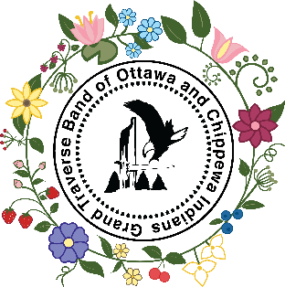

Recipe Submission Form
CHR Sub-Department

Fill out the form completely
Send completed forms to Tamra.Newton@gtb-nsn.gov to be
entered in a drawing for one of three prizes! (Three Winners!)
Prizes: Beaded Earrings, Beaded Keychain, and Beaded Pin
All forms must be submitted by April 1st, 2026!
Drawing will be on April 3rd, 2026. Winner will be contacted via phone.

First/Last Name

Phone Number

Address

City/State/Zip

Recipe Title

Description of Recipe

A short summary or

background story

about the recipe
UNIT TYPES

celsius = C  fahrenheit = F  milliliter = ml  liter = L  milligram = mg  gram = g  kilogram = kg  millimeter = mm  centimeter = cm  meter = m | teaspoon = tsp.  tablespoon = tbsp.  cup = c.  quart = qt.  ounce = oz.  pint = pt.  gallon = gal.  inch – in.  pound = lb.

LIST OF INGREDIENTS A SPECIFIC LIST WITH EXACT MEASUREMENTS. (E.G., “1/2 CUP OF WHOLE MILK”, NOT “MILK”) |  | QUANTITY  and UNIT

COOKING STEPS PLEASE INCLUDE ANY SPECIFIC DETAILS.
(E.G., OVEN DEGREE, COOK TIME, ECT.)

MIIGWETCH FOR YOUR PARTICIPATION!

